**Exp 2**

import tensorflow

from tensorflow import keras

from tensorflow.keras import Sequential

from tensorflow.keras.layers import Dense,Flatten

(X_train,y_train),(X_test,y_test) = keras.datasets.mnist.load_data()

X_test.shape

y_train

import matplotlib.pyplot as plt

plt.imshow(X_train[5])

X_train = X_train/255

X_test = X_test/255

X_train[0]

model = Sequential()

model.add(Flatten(input_shape=(28,28)))

model.add(Dense(128,activation='relu'))

model.add(Dense(32,activation='relu'))

model.add(Dense(10,activation='softmax'))

model.summary()

model.compile(loss='sparse_categorical_crossentropy',optimizer='Adam',metrics=['accuracy'])

history = model.fit(X_train,y_train,epochs=25,validation_split=0.2)

y_prob = model.predict(X_test)

y_pred = y_prob.argmax(axis=1)

from sklearn.metrics import accuracy_score

accuracy_score(y_test,y_pred)

plt.plot(history.history['loss'])

plt.plot(history.history['val_loss'])

plt.plot(history.history['accuracy'])

plt.plot(history.history['val_accuracy'])

plt.imshow(X_test[50])

model.predict(X_test[50].reshape(1,28,28)).argmax(axis=1)

Output

Downloading data from <https://storage.googleapis.com/tensorflow/tf-keras-datasets/mnist.npz>

**11490434/11490434** ━━━━━━━━━━━━━━━━━━━━ **2s** 0us/step

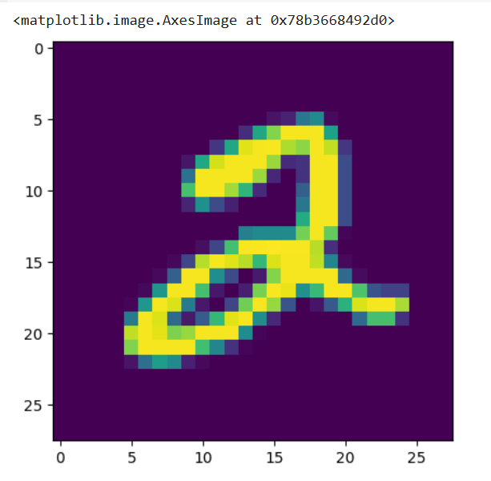

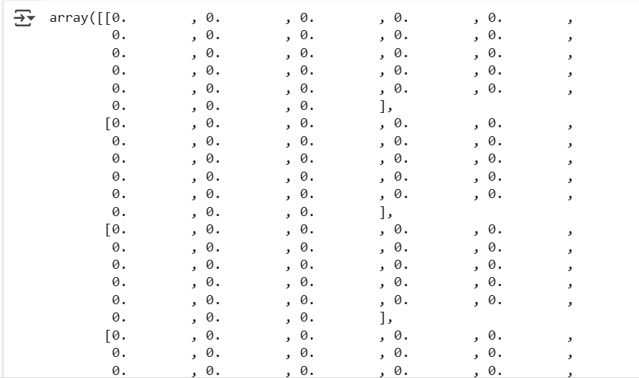

/usr/local/lib/python3.11/dist-packages/keras/src/layers/reshaping/flatten.py:37: UserWarning: Do not pass an `input_shape`/`input_dim` argument to a layer. When using Sequential models, prefer using an `Input(shape)` object as the first layer in the model instead.

super().__init__(**kwargs)

